**Dangar, Anne (1885-1951)**

Anne Dangar is a singular figure in the Australian experience of modernism. Forgotten in her homeland throughout the twentieth century due to her long-term residence in France, she is the only Australian who played a demonstrably productive and expansive role in Cubism. From the 1930s, her synthesis of rural French folk pottery with Cubist-style surface decoration was an idiosyncratic and unexpected interpretation of modernism. It also tangibly validated the links that Albert Gleizes made between past and present, and medieval and modernist, through a practical direct articulation of his somewhat arcane and specialised derivation of Cubism. Gleizes’ vision of the cultural strength of traditional French rural life and the centrality of Catholicism within his aesthetics increasingly shaped Dangar’s art practice by offering spiritual as well as technical support. Her conversion to Catholicism, in contradiction to her conventional Protestant family, was the outcome of her view of herself as disciple to Gleizes’ holistic social and sacred mission. A detailed and long-term correspondence to Grace Crowley in Sydney from 1930 until Dangar’s death in 1951 certainly provided an unusually direct link between Australian artists and the overseas avant-garde. This surviving correspondence is also highly important within global art history for its candid documentation of Gleizes’ working methods, his theories, and the social and professional interchanges within his circle of associates.

Dangar began her studies in 1916 at Julian Ashton’s art school, working with Grace Crowley as an assistant teacher from 1920 onwards. Together with colleagues Crowley, Rah Fizelle and Dorrit Black, she increasingly questioned the limits of acceptable art in Sydney. She departed Australia with Crowley in 1926, intending to study in Britain, but decided to remain in France. She attended Lhote’s academy but had to return to Australia sooner than Crowley. Just before she left, she discovered Gleizes and became fascinated with the ideas behind his art, but was unable to meet him before she departed. Crowley did make contact with Gleizes, and he issued an immediate invitation for Dangar to return to France and work at his artists’ colony, Moly-Sabata, Sablons. Dangar’s newfound modernist theories were disliked in Sydney, and she was overjoyed to receive the invitation.

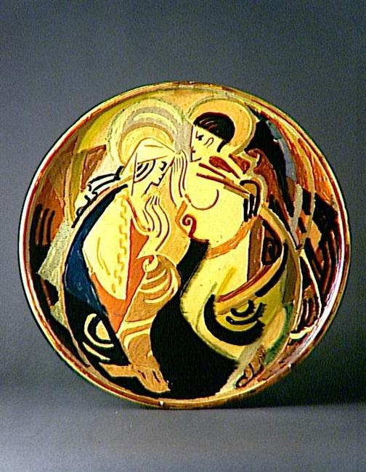

Anne Dangar, *Faïence* plate, 1939, Sèvres Cité de la Céramique, 2 Place de la Manufacture 92310 Sèvres (France) Tél. : [+ 33(0)1 46 29 22 00](tel:%2B%2033%280%291%2046%2029%2022%2000) Mél. : [info@sevresciteceramique.fr](mailto:info@sevresciteceramique.fr)

Spontaneously made and accepted, the invitation caused difficulties to both parties at first. Gleizes was disappointed in Dangar’s abilities as a painter and she was mortified to learn that under the quasi-monastic rule of the community, she was expected to undertake physical work in the garden and house. Whilst she accepted heavy labour as betokening the journey towards a grounded artistic expression and more evolved and collective societal relations, she resented fellow residents. She believed that they were essentially trifling with Gleizes’ theories, as superficial social climbers. Gleizes became more convinced about Dangar’s potential when she began experimenting in local potteries and became a major ambassador for him and the Moly Sabata community via her ceramics. She won medals at the 1937 Paris International exhibition for her pottery and for her teaching of local children’s art classes. Her pottery became very popular and her 1939 appointment as a mentor to revive local potteries in Fez, Morocco indicated her fame.

Dangar spent World War Two in occupied France. In 1943, due to her nationality, she was sent to a holding camp, but was released without being deported to Germany. She shared the privations of the French villagers as well as the complex and confusing political shifts between left and right within the region. Her wartime presence greatly consolidated her acceptance where once language, culture, and class had alienated her. In 1947, she finally managed to establish a pottery studio at Moly Sabata, rather than working at local potteries. Dangar’s reputation amongst local residents was enhanced by her conversion to Catholicism, close to her death, via her interchanges with a local group of monks. This conversion was also regarded as a ratification of Gleizes’ theories. She is remembered equally with Gleizes at Moly-Sabata as a founder of the now revitalised artistic community.

**References and Further Reading**

--- (c 2001) *Anne Dangar at Moly-Sabata: Tradition and innovation* (National Gallery of Australia online resource written for 2001 exhibition of same name) <http://www.nga.gov.au/dangar/index.cfm>

Adams, B. (2004) *Rustic Cubism: Anne Dangar and the Art Colony at Moly-Sabata*, Chicago, University of Chicago Press.

(A comprehensive and wide-ranging discussion of both Dangar and Gleize’s work in a clear sighted aesthetic and socio-political context)

Brooke, P. (2001) *Albert Gleizes – For and Against the Twentieth Century*, New Haven and London, Yale University Press.

(Includes much discussion of Anne Dangar and extensive quotes from her writing)

Foundation Albert Gleizes [online resource] viewed

<http://www.fondationgleizes.fr/fr/gleize/page/fondation/-/fondation>

(The Foundation’s web pages (in French) include a substantial documentation of Anne Dangar’s career)

Topliss, H. (2000) Earth*, Fire, Water, Air: Anne Dangar's Letters to Grace Crowley 1930–1951*, Sydney, Allen & Unwin.

(Detailed annotated compilation of this important primary source interwoven with a narrative about Dangar’s life and work)